**Netaji Subhas University of Technology **

**REPORT FILE**

COMPUTER HARDWARE AND SOFTWARE

**SUBMITTED BY:-**

**Raveesh Gupta (2021UCS1581)**

**Devashis Soren (2021UCS1595)**

**Aryan Gangwar (2021UCS1606)**

**Project Title: Power BI**

Power BI is a powerful business analytics tool developed by Microsoft. It is a collection of software services, apps, and connectors that work together to turn your unrelated sources of data into coherent, visually immersive, and interactive insights. Your data might be an Excel spreadsheet, or a collection of cloud-based and on-premises hybrid data warehouses. Power BI lets you easily connect to your data sources, visualise and discover what's important, and share that with anyone or everyone you want.

Here are some tasks that can be performed with the help of Power BI 1.**Data Visualization:**

Create interactive dashboards and reports to visualise sales performance, financial metrics, or operational data Design dynamic charts, graphs, and maps to represent trends, patterns, and insights within the data. Customise visualisations with filters, slicers, and drill-down capabilities for deeper analysis.

2.**Data Analysis:**

Perform ad-hoc data analysis by exploring and manipulating data from multiple sources.Apply advanced analytics techniques such as forecasting, trend analysis, and clustering to uncover insights.

3.**Data Modeling:**

Import and transform data from various sources using Power Query to create a unified data model.Define relationships between different data tables and create calculated columns and measures for analysis.Optimize data models for performance and efficiency by managing data refresh schedules and query optimization.

**TASK 1:**

**1.Explore Power View, Power Query**

**2.Create a table Employee(empid, gender, department, salary, country,year_of_joining) connect to Employee data file. 3.Remove missing gender and department values. 4.Extract year_of_joining column and visualise number of employees w.r.t year of experience in the company.Perform self-join using Power Query.**

**5.Perform self-join using Power Query.**

**6.Aggregate salary with gender and Visualise using Pie chart.**

**Create a table Employee(empid, gender, department, salary, country,year_of_joining) connect to Employee data file.**

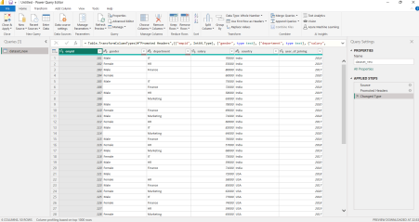

**Remove missing gender and department values.**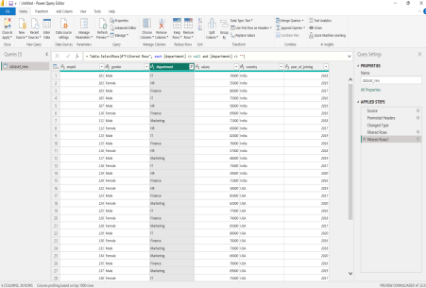

**Extract year_of_joining column and visualise number of employees w.r.t year of experience in the company.**

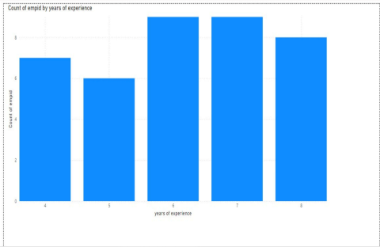

**Perform self-join using Power Query.**

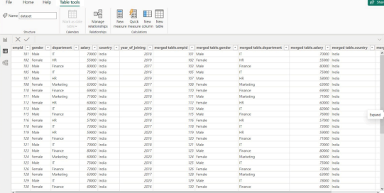

**Aggregate salary with gender and Visualise using Pie chart.**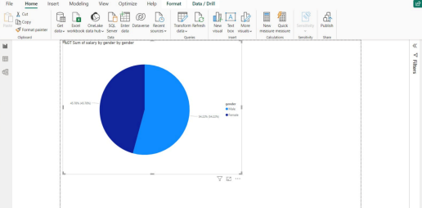

**Task 2:-**

**Visualise the result of any Machine Learning algorithm on any dataset of your choice in PowerBI.**

